Thermo Nicolet iS10 Infrared Spectrometer
Sign the logbook. Turn on the computer, start the Omnic program, and maximize the program window.
With no sample (the ATR anvil can be up), click on the Collect Background icon. Add to window: No. Every 100 minutes the program will ask to have the background run again.
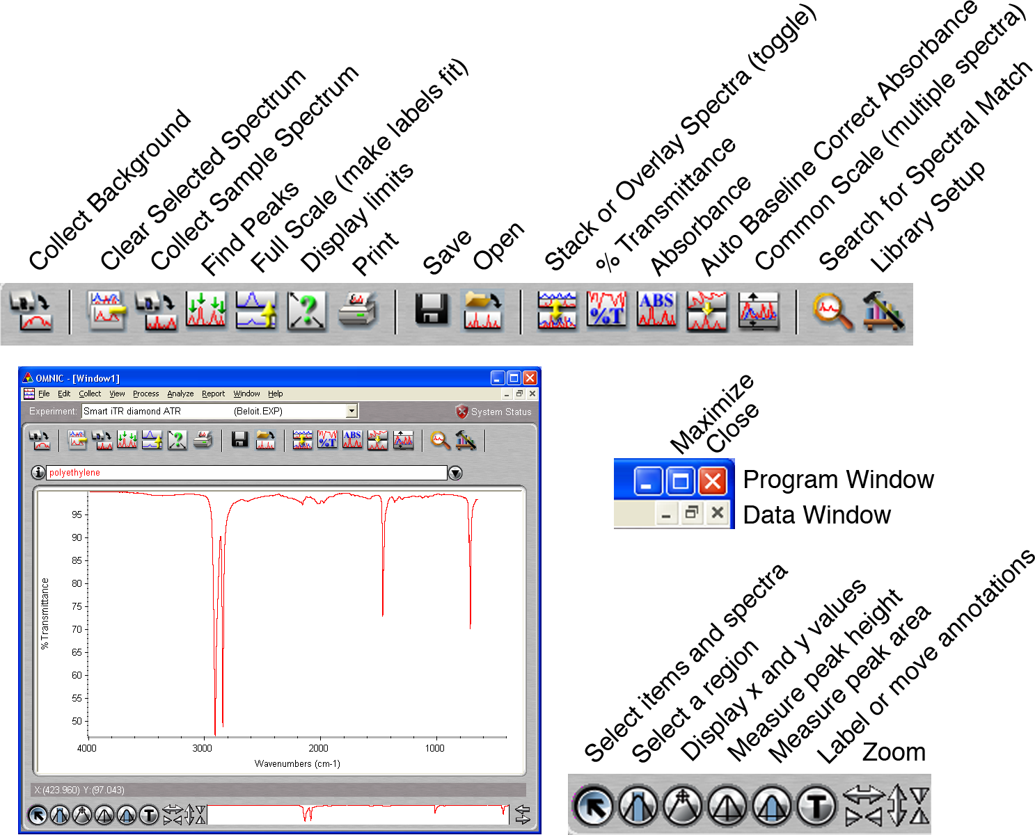
Put the sample in the instrument. For solid ATR turn the knob just until you hear a click. Click on the Collect Sample Spectrum icon. Title is part of the printed report. The spectrum will be displayed after collection. Add to window: Yes.

Normally you would click on Find peaks, adjust the threshold, click on Replace, click on Full scale and then click on the Print icon.

To delete a spectrum, click on the spectrum, then click on Clear Selected Spectrum.

To clean the ATR plate, put a drop of isopropanol on a small tissue and wipe off the plate. Please do not squirt liquid onto or into the instrument or push solid to the edge of the almunium disk.

To label peaks, click on the Find Peaks icon. Click on the spectrum at the height you wish to define as a peak. All peaks larger than that height will be labeled. Click again to pick a different height. Be sure to click on Replace (upper right corner) when finished adjusting peak height. Do not click on the button labeled “print” in this window. If necessary in the main window, click on the Full Scale icon to make the labels fit on the screen.  To display only a portion of the spectrum, use the zoom arrows or drag on the edges of the white box at the bottom right or click on the Display Limits icon to numerically set the plotted range.  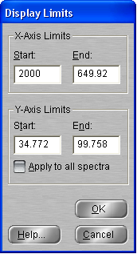 | 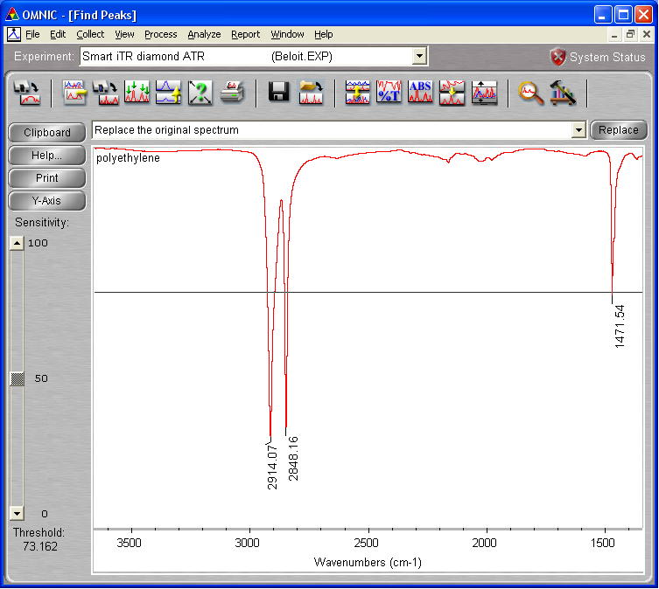  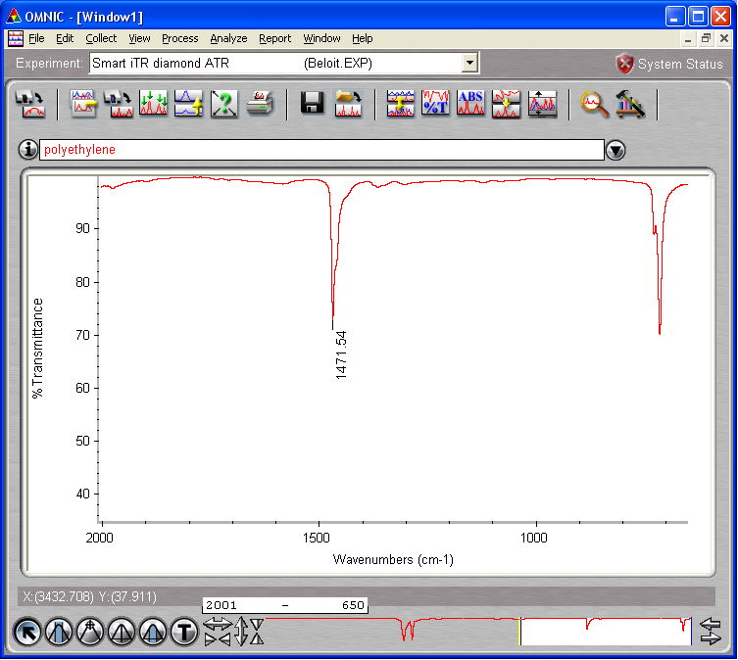
When comparing spectra, overlay works better in color and stacked works better in black and white. You can switch between them using the toggle icon.
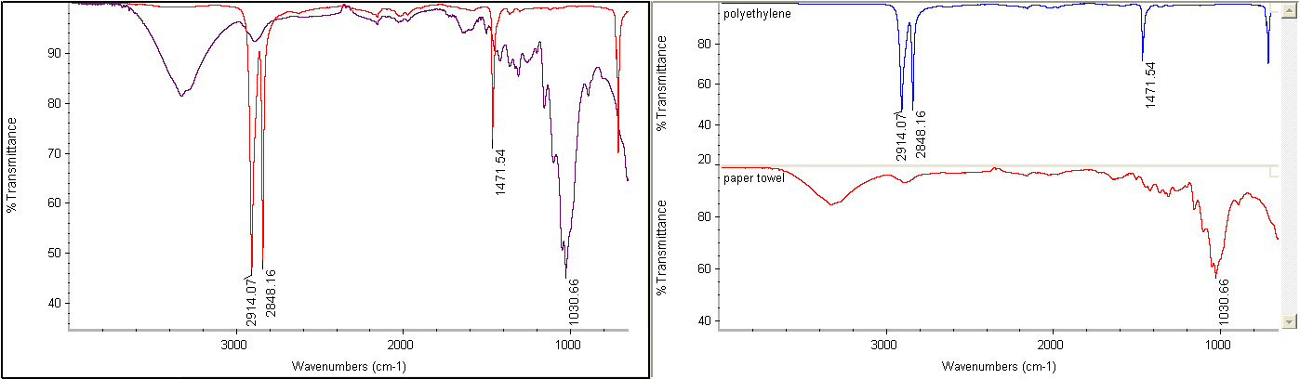

You can search for a spectral match in a library. (If some peaks are offscale you can select only a portion of the spectrum for matching by clicking on the Select a Region tool and dragging on the spectrum.) Click on the Search for Spectral Match icon for a list of possible compound identifications.
To correct a sloping baseline (especially for samples ground in KBr and pressed into a pellet), click on Absorbance, click on Auto Baseline Correct Absorbance, and then click on % Transmittance. The original and the corrected spectrum will both be displayed. Click on one of them with the Select tool, then click on the Clear Selected Spectrum icon.

